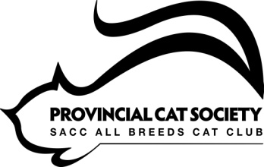

PROVINCIAL CAT SOCIETY
MEMBERSHIP
2019
R100.00 per Member or Family per Year
'The Provincial Cat Society (PCS) is an ALL BREEDS CAT CLUB.
PCS is affiliated to the Southern Africa Cat Council (SACC).
PCS abides by the rules of the Governing Council of the Associated Cat Clubs of South Africa.

 | NEW MEMBER |  | RENEWAL

SURNAME
NAMES OF FAMILY MEMBERS
EMAIL
CELL NUMBER
OTHER CONTACT NUMBER

BREEDERS
CATTERY PREFIX
BREED/S
Would you like to receive entry forms to local cat shows?

PAYMENT RECIEVED
PAYMENT TO BE ELECTRONICALLY TRANSFERRED
 -*/3* /9+
""6+%8-"+38/8," -2;<<<;=;"-.3% 2<>

PROVINCIAL CAT SOCIETY- ABSA BANK, DURBAN.
ACCOUNT NUMBER: 713633747. BRANCH CODE: 632005
Email Proof of Payment to provincialcatsociety@gmail.com
0  ,6 00. 78 9"0 /32:&:
%*- /% 3*/#(' 11$2 -*/3* /9+
""6+%8-"+38/8," -2;<<<;=;"-.3% 2<>
!

DECLARATION
I wish to become a member of PCS for 2019 and agree to uphold the rules and Code of Ethics of this club and always act in accordance with SACC rules.
SIGNATURE |  | DATE

