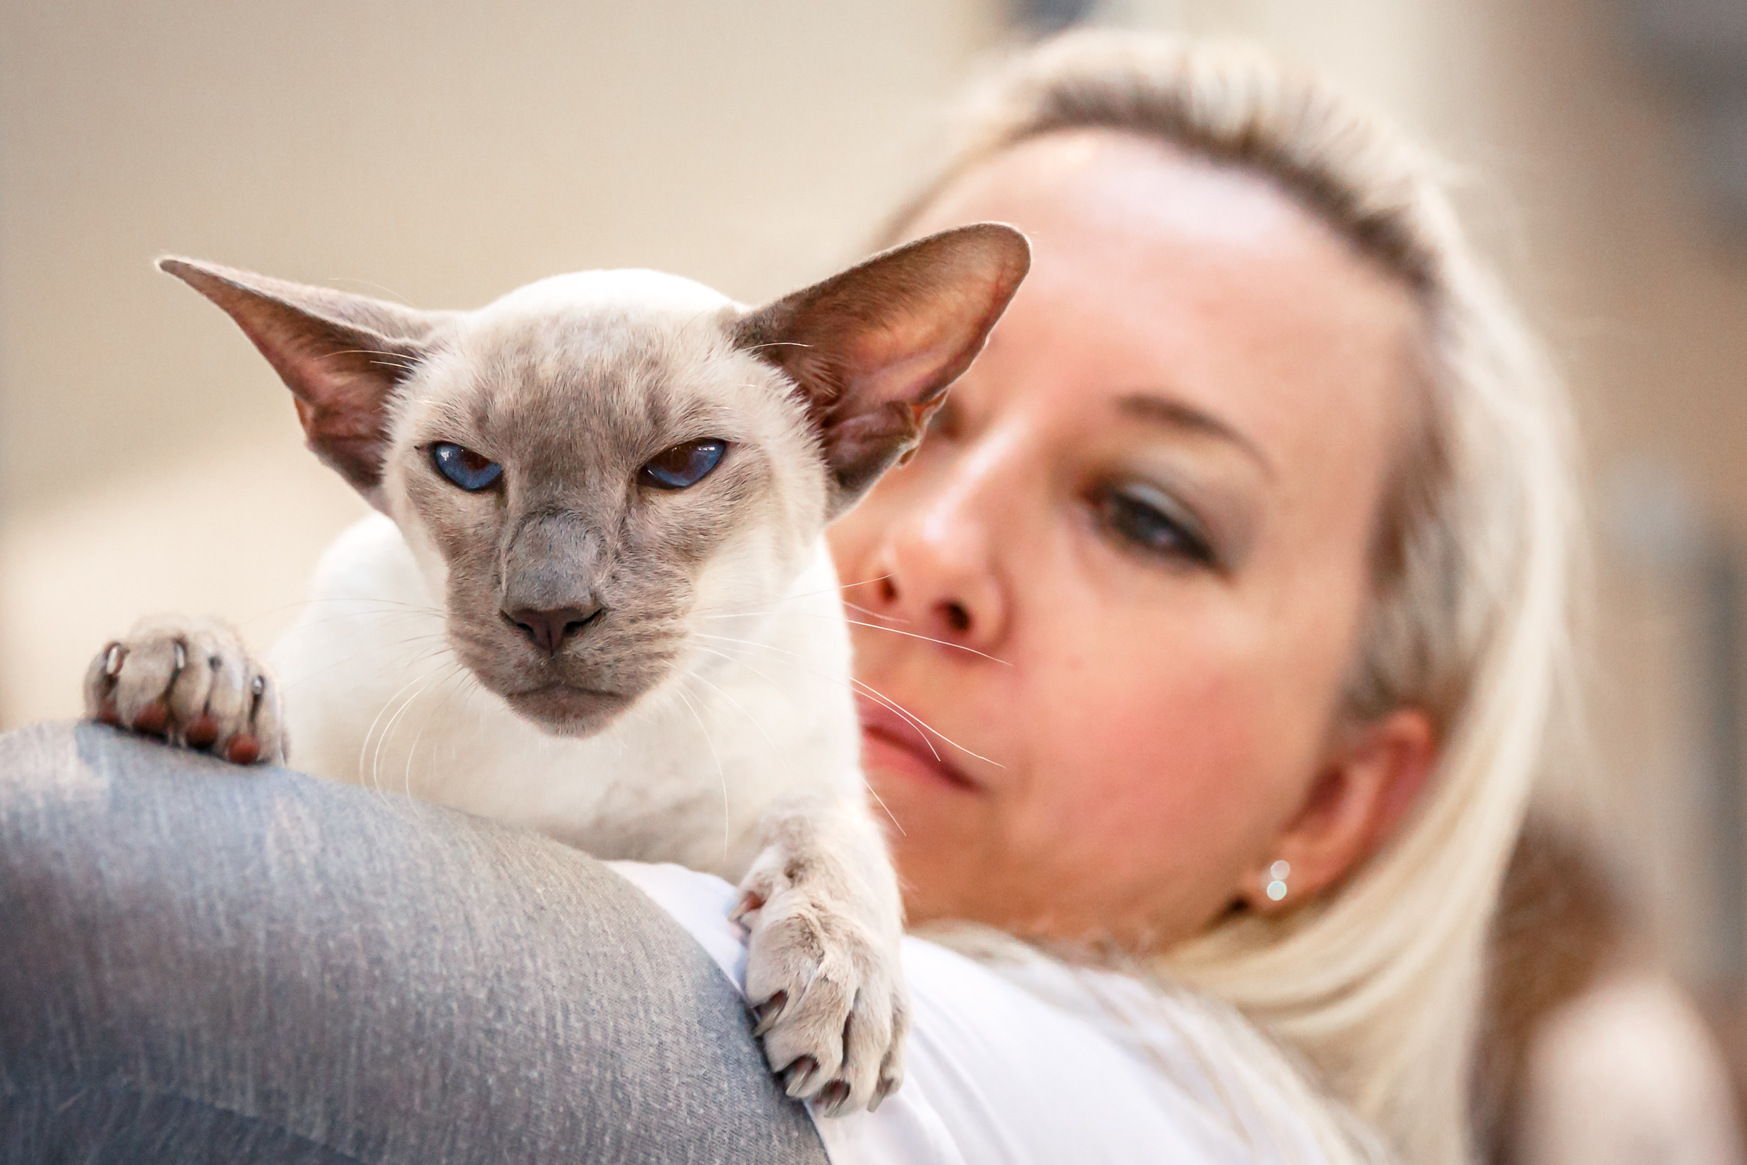 | Charlotte van der Riet  Email Address:charlottevdriet@gmail.com  Website/Portfolio:N/A
CAT JUDGING
Judging Qualifications
2018
- Completed Colour Course - 2010
- Persian/ Exotic/ Chinchilla Longhair – Qualified 2012
- Siamese/Oriental – Qualified 2016
- Medium Hair Breeds – Qualified 2018
- Foreign Breeds – Qualified 2018

Final Status: Qualified to Judge All Breeds.

International Judging
None
CAT FANCY INVOLVEMENT

Breed Group – Siamese Breeders’ Group of South Africa
2004 - present
- Member since 2004
- Honorary Secretary – 2008 - 2013
- Chairperson – 2014-2015
- Breed Council Delegate – 2015 - 2018
- Editor – 2016 - 2018

Club – Western Province Cat Club
2008 - present
- Committee Member - 2008
- Honorary Secretary - 2016
- Membership Secretary - 2016

Judges Council
2011 - 2012
- Secretary
- Organiser of Judges Symposium and Workshop, Cape Town, 10-11 November 2012

Cat of the Year
- 12 August 2017, Cape Town - Organising Committee Member
CAT BREEDING
Registered Cattery
2004 - present
Mai-Thai

Breed/s
- Siamese – seal, blue, chocolate, lilac and tabbypoint varieties
- Oriental – black, blue, chocolate, lilac and spotted tabby varieties

Cat Show History
- Keen Exhibitor since late 1987
- Active Steward since 2007
- Breeder of 6 Cat of the Year qualifiers
- Owner of 1 Cat of the Year winner (2012)
SKILLS
Languages Spoken – English, Afrikaans
Languages Written – English, Afrikaans

