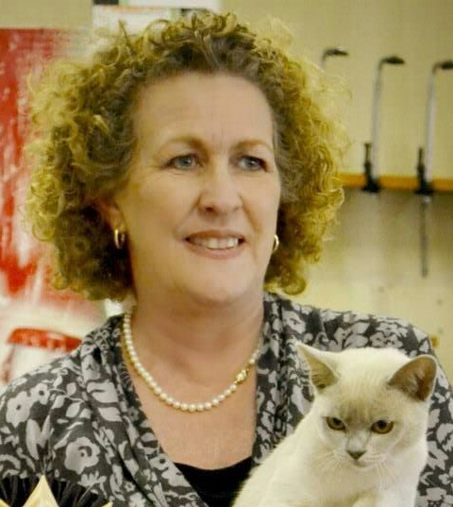 | Jane Goble  Email Address:goblejane@yahoo.com  Website: www.melacattery.com
CAT JUDGING
Judging Qualifications
Approx Date/s
- Persian/ Exotic/ Chinchilla Longhair: 2008
- Siamese/Oriental: 2006
- Medium Hair Breeds: 2011
- Foreign Breeds: 2014

Final Status: Qualified to Judge All Breeds. 2014

International Judging
Australia: Brisbane, Sydney, Melbourne, Perth
CAT FANCY INVOLVEMENT
Club/s
Dates
- Chairperson PCS since 2009.
- Show manager when not judging.

Governing Council
Dates
- Vice President 2016-2017
- Provincial Cat Society Club Delegate to SACC Governing Council

Judges Council
Dates
- Secretary 2016-2017
- Organizer of Judges Symposium and Workshop.

Cat of the Year
- 2016 Show Manager
CAT BREEDING
Registered Cattery/Catteries
Date: Mela Cattery registered with SACC in 1998

Breed/s
- Burmese

Cat Show History
- I have successfully shown and bred numerous Burmese. Mela Cattery has won Cat of the day at numerous shows. Winning cats have included cats bred and owned by myself, cats bred and shown by another exhibitor and cats bred by another breeder and shown by myself. I have imported 8 cats over the years to contribute to the genetic diversity of the breed. I have exported cats to Europe. I have bred 2 Cat of the Year winners and owned a 3rd Cat of the Year
- I have won Brood Queen of the Year and Runner up Stud of the Year
- Have been awarded Runner up Breeder of the Year on 2 occasions
CAT RELATED ARTICLES WRITTEN OR PRESENTED
Title
2017
- Comparing the European and American Burmese researched and presented at SACC Judges Symposium.
SKILLS
Languages Spoken – English
Languages Written – English

