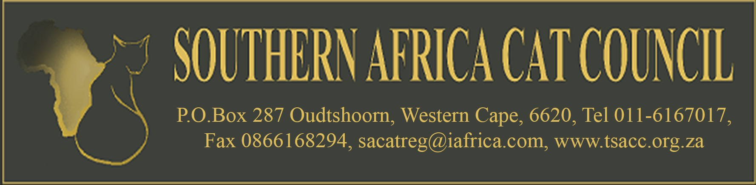

OFFICIAL SUSPENSION LIST (SACRD13)

Last Updated: June, 2021

# | NAME OF MEMBER | CATTERY NAME  (PREFIX) | DATE | SUSPENSION STATUS
1. | V Spacey | - Wrevenick &  - Wolfpack | November 2006 | Permanent
2. | Y Schmiedeskamp | - Pointers | November 2007 | Permanent
3. | I King | - Takara | November 2008 | Permanent
4. | R Bloemhoff | - Mistbesque | June 2010 | Indefinite
5. | C Rudolph | - Cuumba | June 2010 | Permanent
6. | Paul Kaminsky &  Rose Wilson | - Kamsky  - Iceland | July, 2011 | Suspended for 1 year-  To be reviewed on request
7. | Herman van Noordwyk | - Yalinka | February, 2012 | Permanent
8. | Mariette Burger | - LaMaska | October, 2012 | Permanent
9. | Linet Coetzer | - Caziggi | October, 2012 | Permanent refusal
10. | Johan van Eerden | - L’Unique | November 2020 | Permanent
11. | Claudette du Toit | - Furrless | June 2021 | 6 months suspension- review November 2021
Reasons for possible suspension from SACC:
*(Please note that this list is non-exhaustive)
- Not adhering to the SACC Breeder Code of Good Practice
- Breach of the SACC Registration rules
- Fraudulent pedigrees
- General, unbecoming conduct of Members & Breeders
- Breach of the SACC Show rules

